Survival Analysis HW 2

Victor Feagins

9/20/2021

## 4.1 Consider the survival time of the 30 melanoma patients in Table 3.1.

df.3.1 <- read_excel("Table 3.1.xlsx")

## New names:  
## * Uncensor -> Uncensor...10  
## * Uncensor -> Uncensor...12

head(df.3.1, 10) %>%   
 flextable() %>%   
 set_caption("First 10 Observations")

Table 1:First 10 Observations

| Patient | Age | Gender | Stage-II | Stage-III A | Stage-III B | Stage-IV A | Treatment | Remission Time | Uncensor...10 | Survival Time | Uncensor...12 |
| --- | --- | --- | --- | --- | --- | --- | --- | --- | --- | --- | --- |
| 1 | 59 | 0 | 0 | 0 | 1 | 0 | 1 | 33.7 | 0 | 33.7 | 0 |
| 2 | 50 | 0 | 0 | 0 | 1 | 0 | 1 | 3.8 | 1 | 3.9 | 1 |
| 3 | 76 | 1 | 0 | 0 | 1 | 0 | 1 | 6.3 | 1 | 10.5 | 1 |
| 4 | 66 | 0 | 0 | 0 | 1 | 0 | 1 | 2.3 | 1 | 5.4 | 1 |
| 5 | 33 | 1 | 0 | 0 | 1 | 0 | 1 | 6.4 | 1 | 19.5 | 1 |
| 6 | 23 | 0 | 0 | 0 | 1 | 0 | 1 | 23.8 | 0 | 23.8 | 0 |
| 7 | 40 | 0 | 0 | 0 | 1 | 0 | 1 | 1.8 | 1 | 7.9 | 1 |
| 8 | 34 | 1 | 0 | 0 | 1 | 0 | 1 | 5.5 | 1 | 16.9 | 0 |
| 9 | 34 | 1 | 0 | 0 | 1 | 0 | 1 | 16.6 | 0 | 16.6 | 0 |
| 10 | 38 | 0 | 1 | 0 | 0 | 0 | 1 | 33.7 | 0 | 33.7 | 0 |

### Compute and plot the PL estimates of the survivorship functions $S(t)$ of the two treatment groups and check your results with Table 3.2 and Figure 3.1.

surv.model <- Surv(df.3.1$`Survival Time`, event = df.3.1$Uncensor...12)

km <- survfit(surv.model ~ Treatment, data = df.3.1)  
summary(km)

## Call: survfit(formula = surv.model ~ Treatment, data = df.3.1)  
##   
## Treatment=0   
## time n.risk n.event survival std.err lower 95% CI upper 95% CI  
## 6.9 19 1 0.947 0.0512 0.852 1.000  
## 7.7 18 1 0.895 0.0704 0.767 1.000  
## 8.0 16 1 0.839 0.0854 0.687 1.000  
## 8.3 13 1 0.774 0.1003 0.601 0.998  
## 24.4 3 1 0.516 0.2211 0.223 1.000  
##   
## Treatment=1   
## time n.risk n.event survival std.err lower 95% CI upper 95% CI  
## 3.9 11 1 0.909 0.0867 0.754 1.000  
## 5.4 10 1 0.818 0.1163 0.619 1.000  
## 7.9 9 1 0.727 0.1343 0.506 1.000  
## 10.5 8 1 0.636 0.1450 0.407 0.995  
## 19.5 4 1 0.477 0.1755 0.232 0.981

The survival times are the same with Table 3.2 in the book.

ggsurvplot(km)

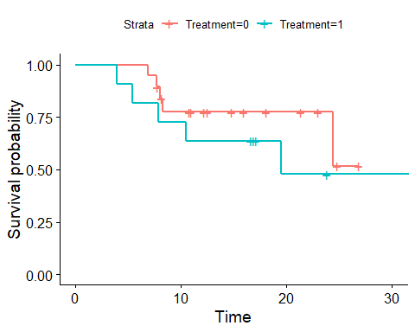

The survival curves are the same as figure 3.1 in the book.

### Compute the variance of $S(t)$ for every uncensored observation.

The following equation is used to calculate the variance of $S(t)$.



Where $n$ is number of observations and $r$ is number of deaths.

surv.data <- tidy(km)  
  
surv.var <- surv.data %>%  
 filter(n.event == 1) %>% #Looking only at uncensored observations  
 group_by(strata) %>%   
 mutate(S.Var = estimate^2 * cumsum(1/((max(n.risk)-cumsum(n.event))*(max(n.risk)-cumsum(n.event) + 1))))  
  
surv.var %>%   
 select(time, strata, S.Var) %>%   
 flextable() %>%   
 set_caption("Surival Function Variences")

Table 2:Surival Function Variences

| time | strata | S.Var |
| --- | --- | --- |
| 6.9 | Treatment=0 | 0.002624289 |
| 7.7 | Treatment=0 | 0.004956991 |
| 8.0 | Treatment=0 | 0.006943539 |
| 8.3 | Treatment=0 | 0.008414419 |
| 24.4 | Treatment=0 | 0.005008582 |
| 3.9 | Treatment=1 | 0.007513148 |
| 5.4 | Treatment=1 | 0.013523666 |
| 7.9 | Treatment=1 | 0.018031555 |
| 10.5 | Treatment=1 | 0.021036814 |
| 19.5 | Treatment=1 | 0.017256762 |

### Estimate the median survival times of the two groups

print(km)

## Call: survfit(formula = surv.model ~ Treatment, data = df.3.1)  
##   
## n events median 0.95LCL 0.95UCL  
## Treatment=0 19 5 NA 24.4 NA  
## Treatment=1 11 5 19.5 10.5 NA

For treatment 0 the median is undefined since the is still more then 50% of patients alive.

## 4.4 Consider the remission data of 42 patients with acute leukemia in Example 3.3.

## [1] "Placebo"

## [1] 1 1 2 2 3 4 4 5 5 8 8 8 8 11 11 12 12 15 17 22 23

## [1] "6-MP"

## [1] 6 6 6 7 10 13 16 22 23 6+ 9+ 10+ 11+ 17+ 19+ 20+ 25+ 32+ 32+  
## [20] 34+ 35+

### Compute and plot the PL estimates of $S(t)$ at every time to relapse for the 6-MP and placebo groups.

km <- survfit(surv.model.3.3 ~ treatment, data = df.3.3)  
summary(km)

## Call: survfit(formula = surv.model.3.3 ~ treatment, data = df.3.3)  
##   
## treatment=6-MP   
## time n.risk n.event survival std.err lower 95% CI upper 95% CI  
## 6 21 3 0.857 0.0764 0.720 1.000  
## 7 17 1 0.807 0.0869 0.653 0.996  
## 10 15 1 0.753 0.0963 0.586 0.968  
## 13 12 1 0.690 0.1068 0.510 0.935  
## 16 11 1 0.627 0.1141 0.439 0.896  
## 22 7 1 0.538 0.1282 0.337 0.858  
## 23 6 1 0.448 0.1346 0.249 0.807  
##   
## treatment=Placebo   
## time n.risk n.event survival std.err lower 95% CI upper 95% CI  
## 1 21 2 0.9048 0.0641 0.78754 1.000  
## 2 19 2 0.8095 0.0857 0.65785 0.996  
## 3 17 1 0.7619 0.0929 0.59988 0.968  
## 4 16 2 0.6667 0.1029 0.49268 0.902  
## 5 14 2 0.5714 0.1080 0.39455 0.828  
## 8 12 4 0.3810 0.1060 0.22085 0.657  
## 11 8 2 0.2857 0.0986 0.14529 0.562  
## 12 6 2 0.1905 0.0857 0.07887 0.460  
## 15 4 1 0.1429 0.0764 0.05011 0.407  
## 17 3 1 0.0952 0.0641 0.02549 0.356  
## 22 2 1 0.0476 0.0465 0.00703 0.322  
## 23 1 1 0.0000 NaN NA NA

ggsurvplot(km)

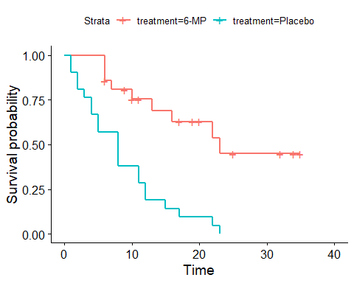

### Compute the variances of $S(10)$ in the 6-MP group and of $S(3)$ in the placebo group.

surv.data <- tidy(km)  
  
surv.var <- surv.data %>%  
 filter(n.event == 1) %>% #Looking only at uncensored observations  
 group_by(strata) %>%   
 mutate(S.Var = estimate^2 * cumsum(1/((max(n.risk)-cumsum(n.event))*(max(n.risk)-cumsum(n.event) + 1))))  
  
surv.var %>%   
 select(time, strata, S.Var) %>%   
 filter(time == 10 | time == 3) %>%   
 flextable() %>%   
 set_caption("Surival Function Variences S(10) & S(3)")

Table 3:Surival Function Variences S(10) &amp; S(3)

| time | strata | S.Var |
| --- | --- | --- |
| 10 | treatment=6-MP | 0.004446435 |
| 3 | treatment=Placebo | 0.002134187 |

### Estimate the median remission times of the two treatment groups.

print(km)

## Call: survfit(formula = surv.model.3.3 ~ treatment, data = df.3.3)  
##   
## n events median 0.95LCL 0.95UCL  
## treatment=6-MP 21 9 23 16 NA  
## treatment=Placebo 21 21 8 4 12

## 4.9 Do a complete life-table analysis of the data given in Exercise Table 4.2, the Angina Pectoris data.

df.4.9 <- haven::read_sas("males.sas7bdat")  
head(df.4.9) %>%   
 flextable() %>%   
 set_caption("First 5 Observations")

Table 4:First 5 Observations

| Years | Censored | Freq |
| --- | --- | --- |
| 0.5 | 0 | 456 |
| 0.5 | 1 | 0 |
| 1.5 | 0 | 226 |
| 1.5 | 1 | 39 |
| 2.5 | 0 | 152 |
| 2.5 | 1 | 22 |

This data is different format of survival data. R handles survival data where each row is an event. So we will need to transform the data by replicated the number of rows by the associated rows frequency

duptimes <- df.4.9$Freq  
idx <- rep(1:nrow(df.4.9), duptimes)  
df.4.9.t <- df.4.9[idx,]

Once that transformation is done survival analysis is the same steps as the previous problems.

surv.model.4.9 <- Surv(df.4.9.t$Years, event = abs(df.4.9.t$Censored-1))

km <- survfit(surv.model.4.9 ~ 1, data = df.4.9.t)  
summary(km)

## Call: survfit(formula = surv.model.4.9 ~ 1, data = df.4.9.t)  
##   
## time n.risk n.event survival std.err lower 95% CI upper 95% CI  
## 0.5 2418 456 0.811 0.00796 0.796 0.827  
## 1.5 1962 226 0.718 0.00915 0.700 0.736  
## 2.5 1697 152 0.654 0.00970 0.635 0.673  
## 3.5 1523 171 0.580 0.01011 0.561 0.600  
## 4.5 1329 135 0.521 0.01028 0.502 0.542  
## 5.5 1170 125 0.466 0.01032 0.446 0.486  
## 6.5 938 83 0.424 0.01035 0.405 0.445  
## 7.5 722 74 0.381 0.01045 0.361 0.402  
## 8.5 546 51 0.345 0.01059 0.325 0.367  
## 9.5 427 42 0.311 0.01077 0.291 0.333  
## 10.5 321 43 0.270 0.01105 0.249 0.292  
## 11.5 233 34 0.230 0.01131 0.209 0.254  
## 12.5 146 18 0.202 0.01173 0.180 0.226  
## 13.5 95 9 0.183 0.01223 0.160 0.208  
## 14.5 59 6 0.164 0.01313 0.140 0.192

### Plot the three survival functions: survival, hazard and density functions.

#### Survival Function

ggsurvplot(km)

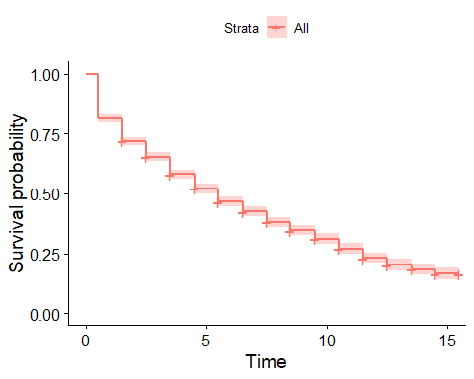

#### Hazard Function

survival.table1 <- broom::tidy(km) %>% filter(n.event > 0)  
survival.table1 <- survival.table1 %>% mutate(hazard = n.event / (n.risk * (lead(time) - time)))  
ggplot() +  
 geom_line(data = survival.table1, aes(x = time, y = hazard)) +  
 labs(x = "Time", y = "Hazard")

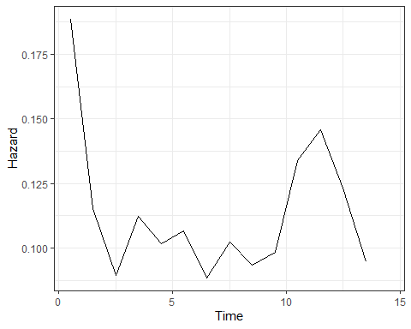

### Probablity

survival.table1 <- survival.table1 %>% mutate(probability = estimate * hazard)  
ggplot() +  
 geom_line(data = survival.table1, aes(x = time, y = probability)) +  
 labs(x = "Time", y = "Probability Density")

